Experiment 5

**Name** : Mohammad Wasi

**SAP ID** : 500110709

**Batch** : AIML B8

Aim: **. Use of different SQL clauses and join**

**Objective :**

1. To list the Deptno where there are no emps.
2. To list the No.of emp’s and Avg salary within each department for each job.
3. To find the maximum average salary drawn for each job except for ‘President’.
4. To List the department details where at least two emps are working.
5. To List the no. of emps in each department where the no. is more than 3.
6. To List the names of the emps who are getting the highest sal dept wise.
7. To List the Deptno and their average salaries for dept with the average salary less than the averages for all departments.

Theory :

SQL commands and keywords play a crucial role in database management. Here's a bit more detail on some commonly used ones:

**SELECT**: This command retrieves data from one or more tables in the database. It allows you to specify which columns you want to retrieve and any filtering criteria using the WHERE clause.

**WHERE**: The WHERE clause filters rows based on specified conditions. It allows you to narrow down the result set by specifying criteria that the rows must meet.

**JOIN**: JOIN is used to combine rows from two or more tables based on a related column between them. It allows you to retrieve data from multiple tables in a single query, linking them together based on a common column.

**ORDER BY:** This clause sorts the result set in ascending or descending order based on one or more columns. It helps in organizing the data for better analysis and presentation.

**Code**

**-- -- 1. List the Deptno where there are no emps.**

SELECT DEPTNO

FROM DEPT

WHERE DEPTNO NOT IN (SELECT DISTINCT DEPTNO FROM EMP);

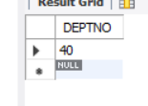

**-- 2. List the No.of emp’s and Avg salary within each department for each job.**

SELECT DEPTNO, JOB, COUNT(*) AS "No. of Emps", AVG(SAL) AS "Avg Salary"

FROM EMP

GROUP BY DEPTNO, JOB;

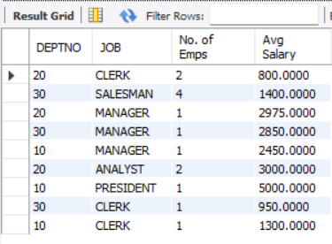

**-- 3. Find the maximum average salary drawn for each job except for ‘President’.**

SELECT JOB, MAX(AVG_SALARY) AS "Max Avg Salary"

FROM (

SELECT JOB, AVG(SAL) AS AVG_SALARY

FROM EMP

WHERE JOB != 'PRESIDENT'

GROUP BY JOB

) sub

GROUP BY JOB;

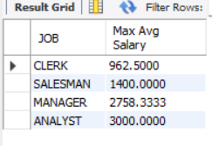

**-- 4. List the department details where at least two emps are working.**

SELECT DEPTNO, DNAME, LOC

FROM DEPT

WHERE DEPTNO IN (SELECT DEPTNO FROM EMP GROUP BY DEPTNO HAVING COUNT(*) >= 2);

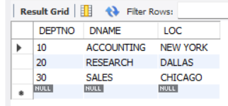

**-- 5. List the no. of emps in each department where the no. is more than 3.**

SELECT DEPTNO, COUNT(*) AS "No. of Emps"

FROM EMP

GROUP BY DEPTNO

HAVING COUNT(*) > 3;

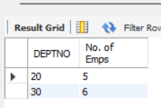

**-- 6. List the names of the emps who are getting the highest sal dept wise.**

SELECT E.ENAME, E.SAL, D.DEPTNO

FROM EMP E

JOIN DEPT D ON E.DEPTNO = D.DEPTNO

WHERE (E.SAL, E.DEPTNO) IN (

SELECT MAX(SAL), DEPTNO

FROM EMP

GROUP BY DEPTNO

);

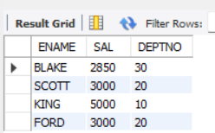

**-- 7. List the Deptno and their average salaries for dept with the average salary less than the averages for all departments.**

SELECT DEPTNO, AVG(SAL) AS "Avg Salary"

FROM EMP

GROUP BY DEPTNO

HAVING AVG(SAL) < (SELECT AVG(SAL) FROM EMP);

